**Instagram Business Profile**

**Business Profile:**

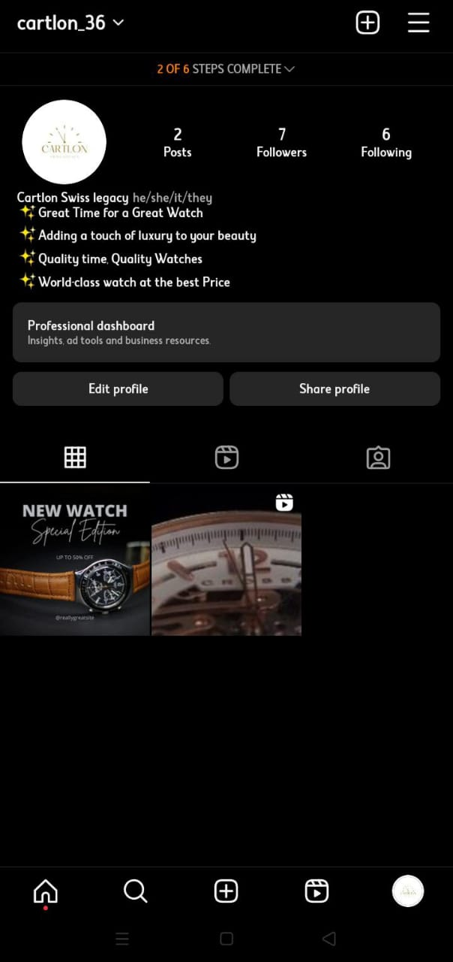

**Instagram Reels video with Maximum 100 likes:**



**Link:** [**https://instagram.com/cartlon_36?igshid=NGVhN2U2NjQ0Yg==**](https://instagram.com/cartlon_36?igshid=NGVhN2U2NjQ0Yg==)

**Video link:** [**https://www.instagram.com/reel/Cypo21yLVz0/?igshid=M2MyMzgzODVlNw==**](https://www.instagram.com/reel/Cypo21yLVz0/?igshid=M2MyMzgzODVlNw==)